**Custom AMI**

1. First create EC2 instance and install Git, Java, Terraform and docker using cli

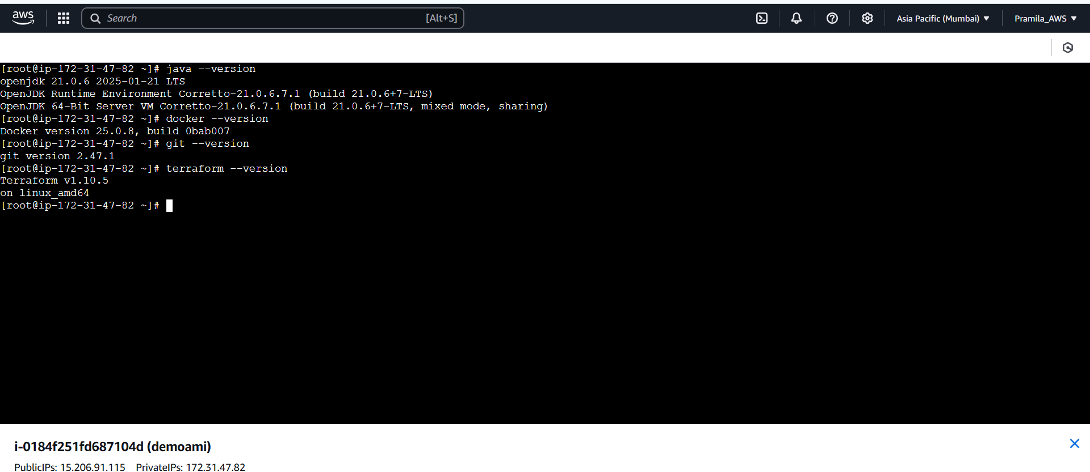

1. Create custom AMI from EC2 instance

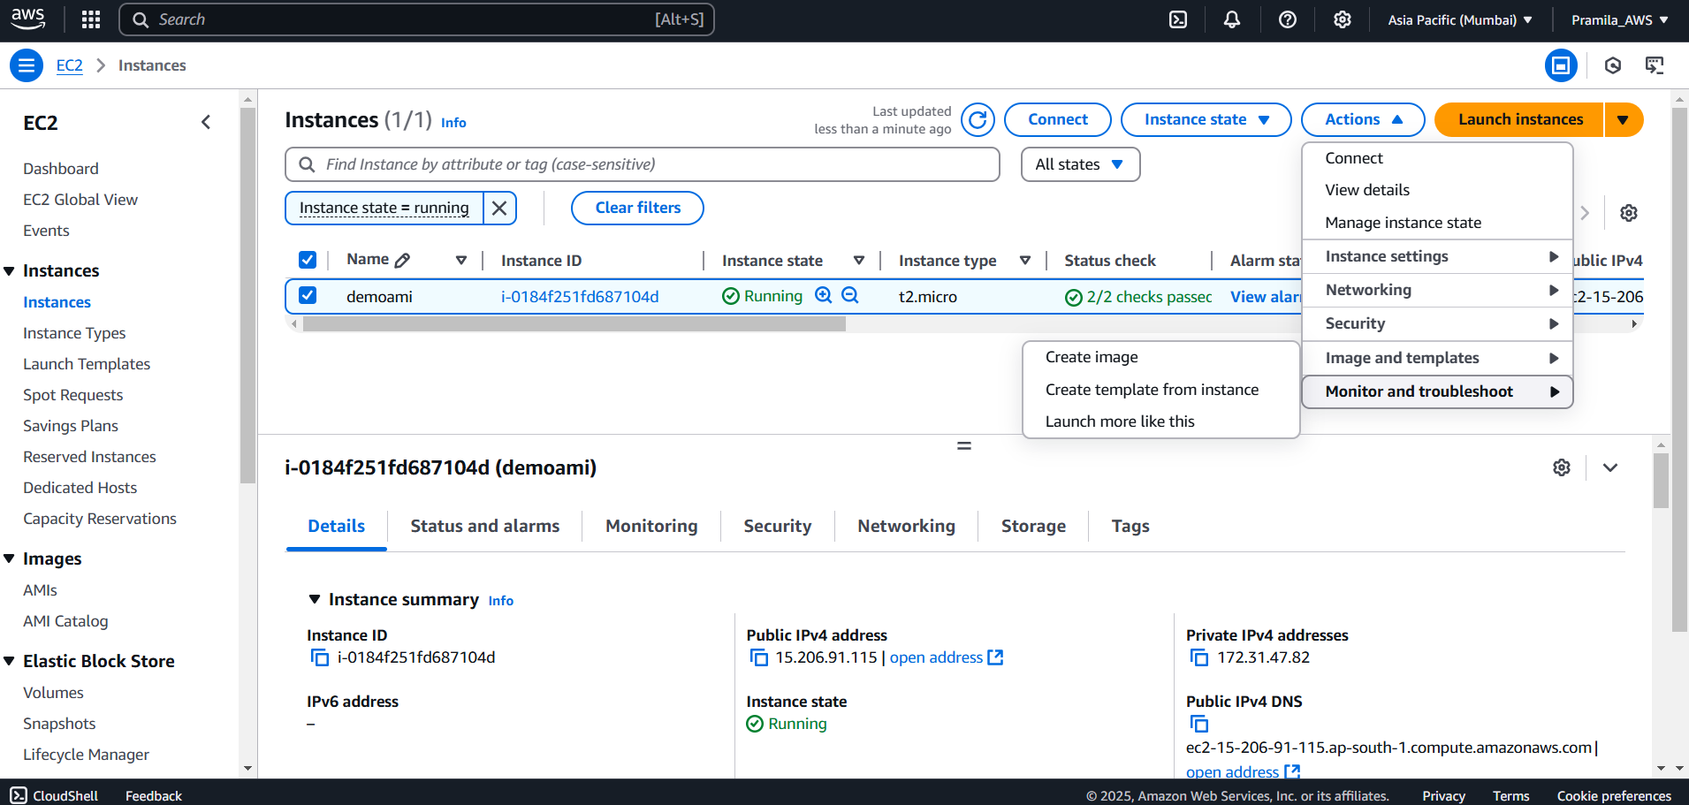

1. Create custom AMI from EC2 instance which is having all applications installed

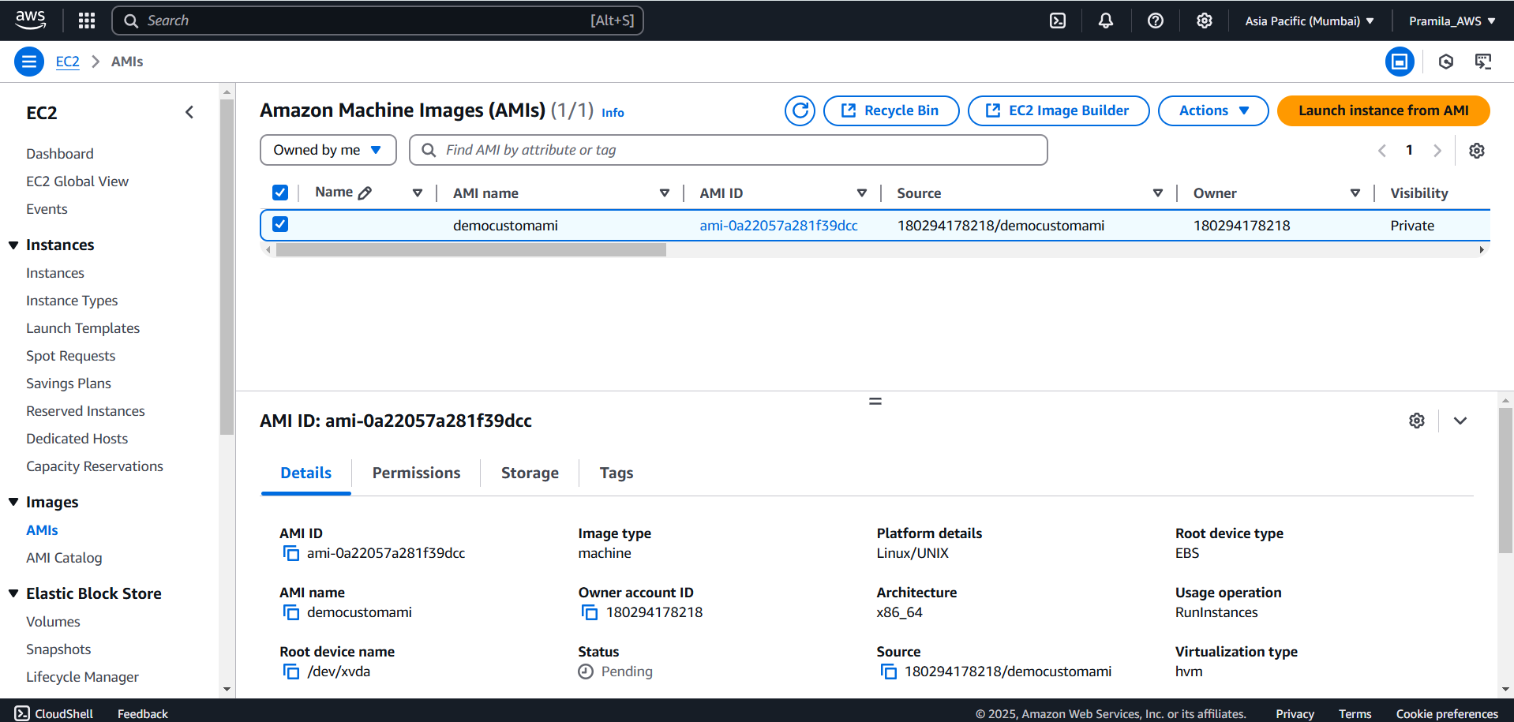

1. Select new created custom AMI while creating new EC2 instance

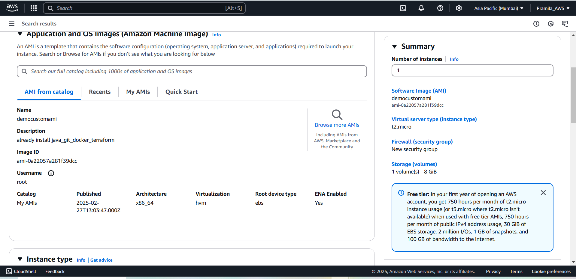

1. Created EC2 instance with new created custom AMI

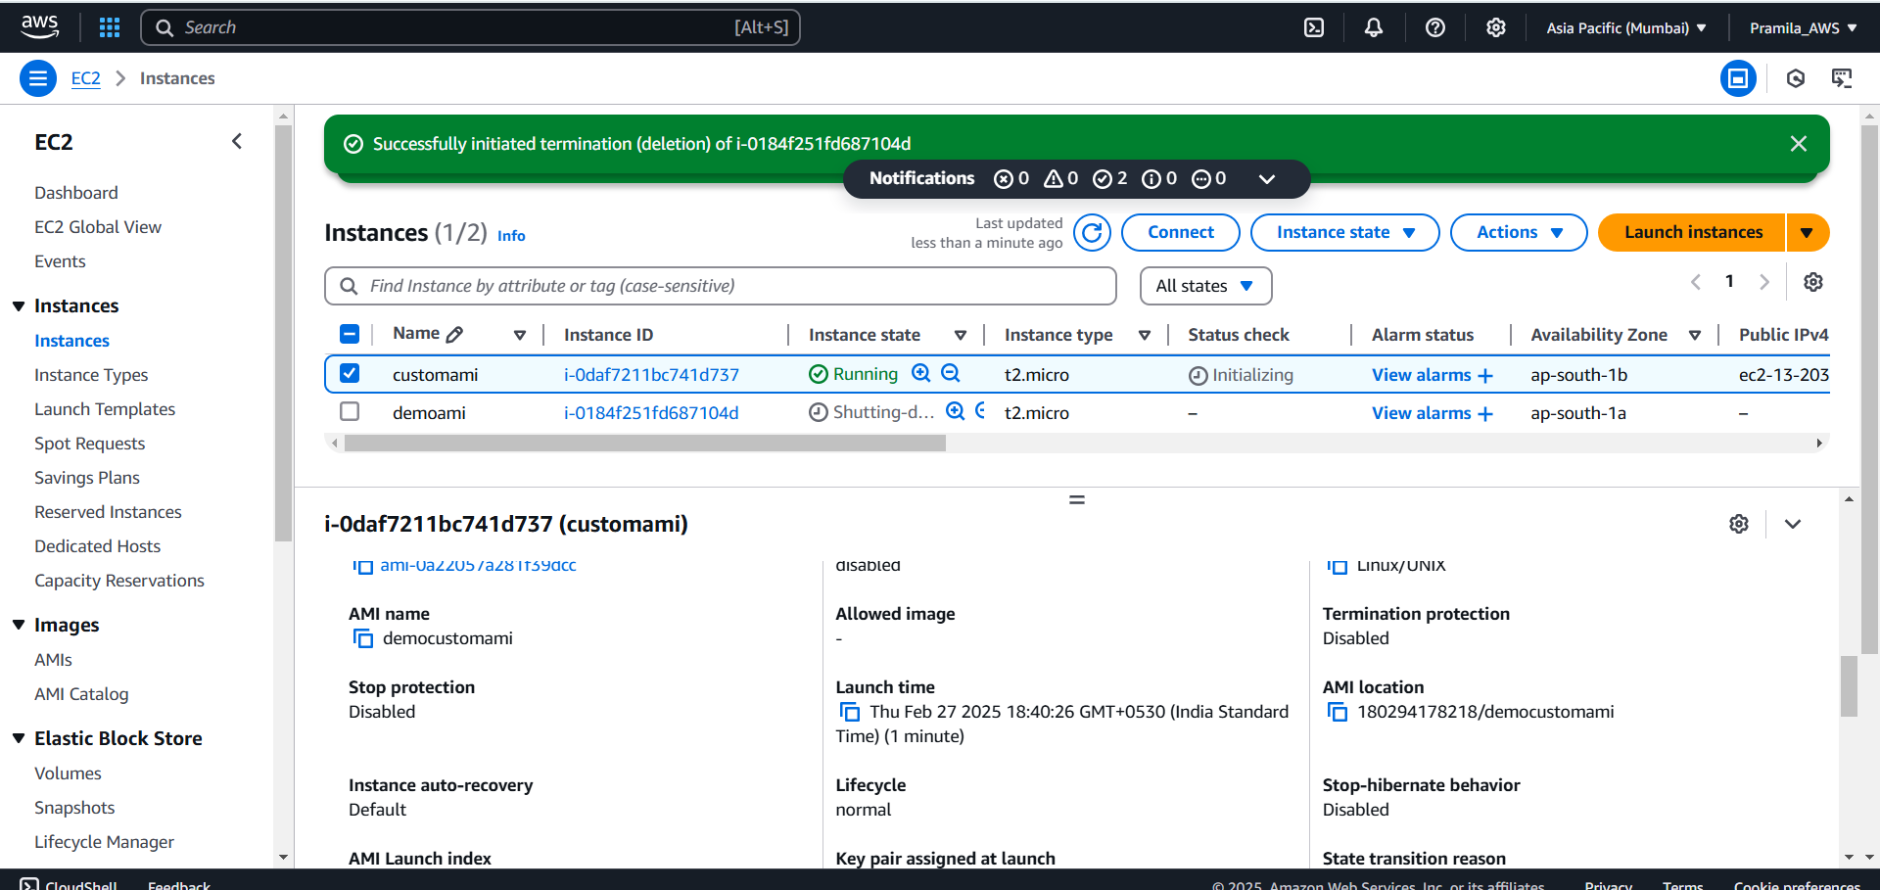

1. All installed software present in new created ec2 instance

